Portfolio overview for the data story

* What was the project?
* Why did you make it?
* What skills, knowledges and processes di you use?
* What did you learn from the project?
* How was the project a success?

**To do**

* Portfolio overview
  + Outline
  + Write
  + Edit
* Introduction
  + Outline
  + Write
  + Figures
    - One
    - Two
  + Edit
* Falling dominance of top 20 percent countries
  + Outline
  + Write
  + Figures
    - One
    - Two
    - Three
    - Four
  + Edit
* A recovery, to some extent.
  + Outline
  + Write
  + Figures
    - One
    - Two
  + Edit
* Who was gaining as the top 20% fell? Outline
  + Outline
  + Write
  + Figures
    - One
  + Edit
* There have been sustain challenges for countries outside the top 50%
  + Outline
  + Write
  + Figures
    - One
    - Two
    - Three
  + Edit
* Concluding
  + Outline
  + Write
  + Edit
* Methods
  + Coding link to notebook (<https://rpubs.com/chrismartin03/964176>)
  + Narrative link to Figma Jam

**Introduction**

* So much of the media reporting around tennis focusses on the biggest stars in the game. Serena, Roger, Rafa and Novak. Players who are known just by their first names.
* The broader trends in the game receive much less attention. I’m thinking of questions like is the top tier of professional tennis becoming more accessible to players outside the very richest countries.
* After years of watching tennis, I did have a hunch that this was the case.
* In this data story I explore if the data backs up my hunch. Before I get into exploring this in detail, lets quickly define what I mean by some of the key terms this introduction.
  + The top tier of professional tennis: I’m going to consider entering the first round of a Grand Slam Singles tournament as the top tier. If you are competing in Grand Slams you are [hopefully breaking even or making money as professional player](https://www.forbes.com/sites/miguelmorales/2013/08/26/aces-into-assets-how-michael-russell-has-made-a-profitable-career-in-the-demanding-world-of-pro-tennis/?sh=7bf3390e4754).
  + The very richest countries: Here, I’m going to say that the richest countries are those with the highest GDP per capita. More specifically, the countries in the 20% for GDP per capita.
  + My years of watching tennis: I’ll look at a trends from 1990 up until 2019. This lines up with when I started watching tennis, the 1990 Wimbledon final between Edberg and Becker is the first one I remember, I think. I’m going to draw a line at 2019 though, as after that I suspect any trends are going to be dominated by the effects of the Covid-19 pandemic.
* In the chart below, we can see that the dominance of the very richest countries did decline between 1990 and around 2010. My hunch was right, at least initially. It does look like there is a bit of recovery, in Grand Slam first round appearances for these countries, after around 2010. The trend at each of the Grand Slam Tournaments looks pretty similar. This is going to be important in a minute.
* The change is dramatic too. In 1990 80% of players appearing in the first round of Wimbledon were from one of the richest countries (last reminder a country in the top 20% by GDP per capita). By 2009 this had fallen to 54%. In raw numbers that equates to there being 205 players from the richest countries in the draw in 1990, and only 138 players in 2009.

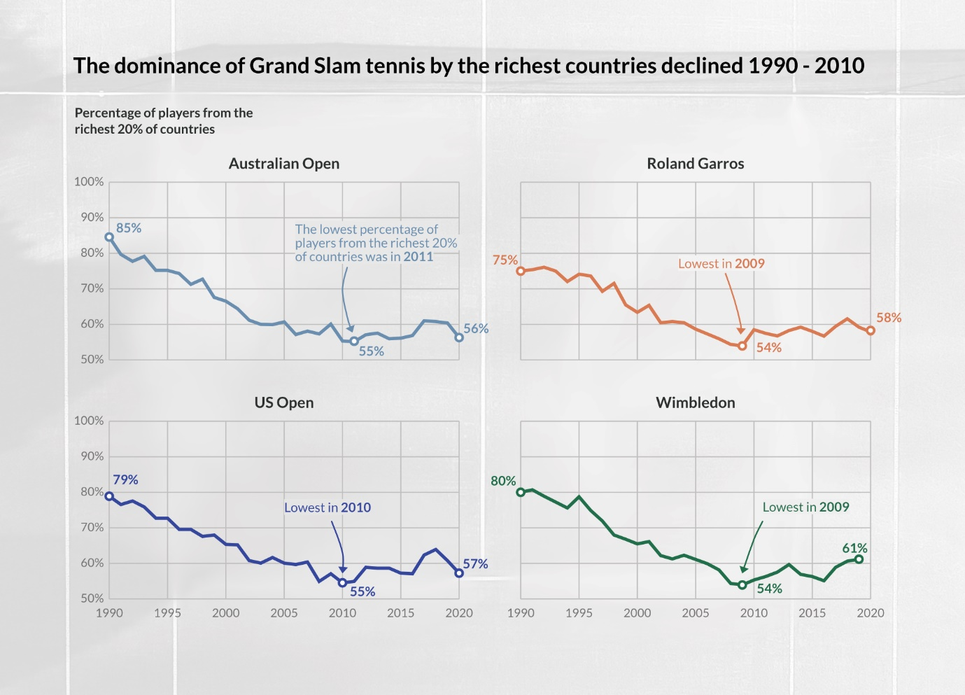

Now if we look at all Grand Slam tournaments together, then we see that the lowest percentage of players from the richest 20% of countries was in 2008.

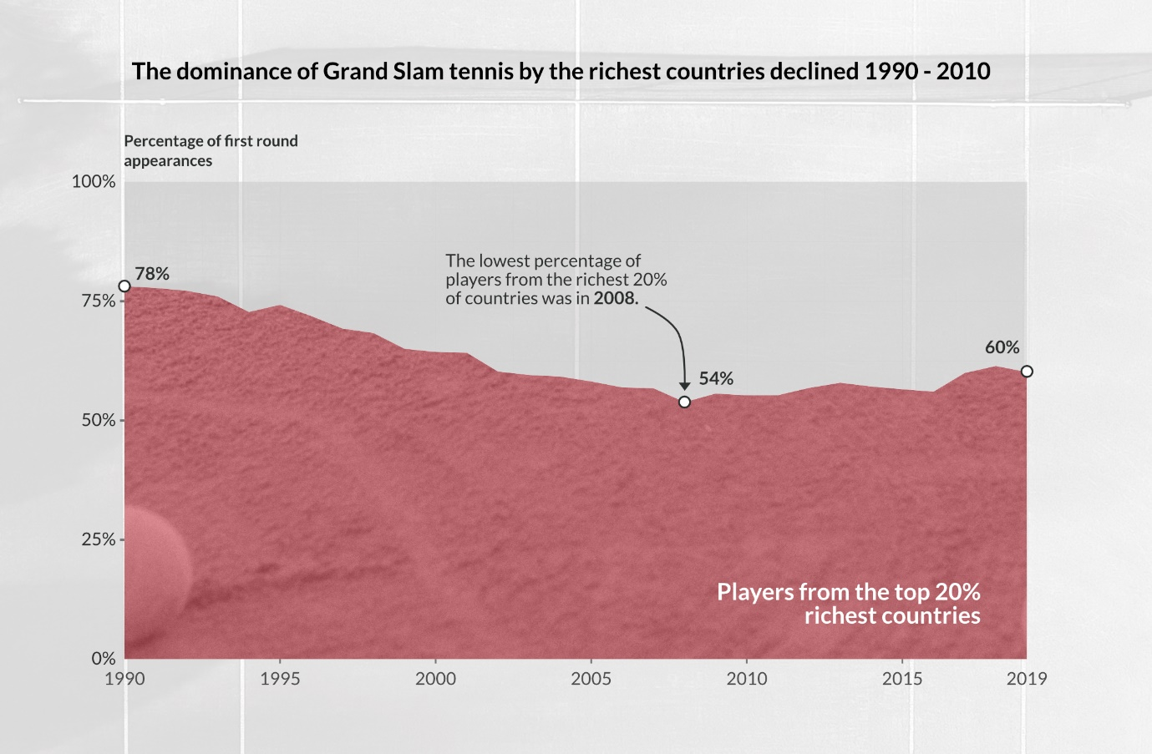

We will be looking at a few charts like this, with all the Grand Slam tournaments together and the ‘percentage of first round appearances’ on the y axis. So, it is worth being clear about what this means. 100% is equal to the 1024 first round appearances made each. That breaks down as 256 first appearances at each Grand Slam, 128 in each of the Women’s and Men’s singles. There is a quick visual representation of this below, which might help as an explainer if things aren’t totally clear yet.



Before digging deeper into the trend I have identified, I want to quickly explain why I chose first round Grand Slam appearance as the ‘metric’ for assessing the richest countries dominance. Basically, If you are a player competing in Grand Slam singles tournaments then you are probably breaking even financially or earn money. If you are interested, there is lots to read about the financial difficulties faced by players outside the top 100 in the world. I would recommend this piece (<https://www.forbes.com/sites/miguelmorales/2013/08/26/aces-into-assets-how-michael-russell-has-made-a-profitable-career-in-the-demanding-world-of-pro-tennis/?sh=7bf3390e4754>) as a starting point.

Having set the scene and established there was something in my tennis fan’s hunch, in the rest of this data-driven story I am going to digger a bit deeper. First, to explore what was going on in the as the dominance of the richest countries fell away, and then experienced a mini-resurgence. Then turning to countries that made, and did not make, gains as the richest countries fell away.

**The richest countries falling away**

The first thing to do, is to confirm that the trends picked up earlier in the essay are meaningful, interesting and tennis related. This means ruling out some potential explanations. Were there big changes in the countries in the top 20% richest? Did a major tennis playing country drop out of the top 20% richest countries some time between 1990 and 2008?

In turns out this was not the case. The group of major tennis playing countries in the richest 20% of countries remained stable. There is a group of countries that has been ever present in the richest 20%. This group includes the countries that have dominated Grand Slam tennis, such as the United States, France and Spain. In the chart below, you can see a second group that did move in and out of the top 20% richest countries. However, these are not countries which have had large numbers of players appearing at Grand Slams. Mostly, they have had fewer than 10 appearances per year.

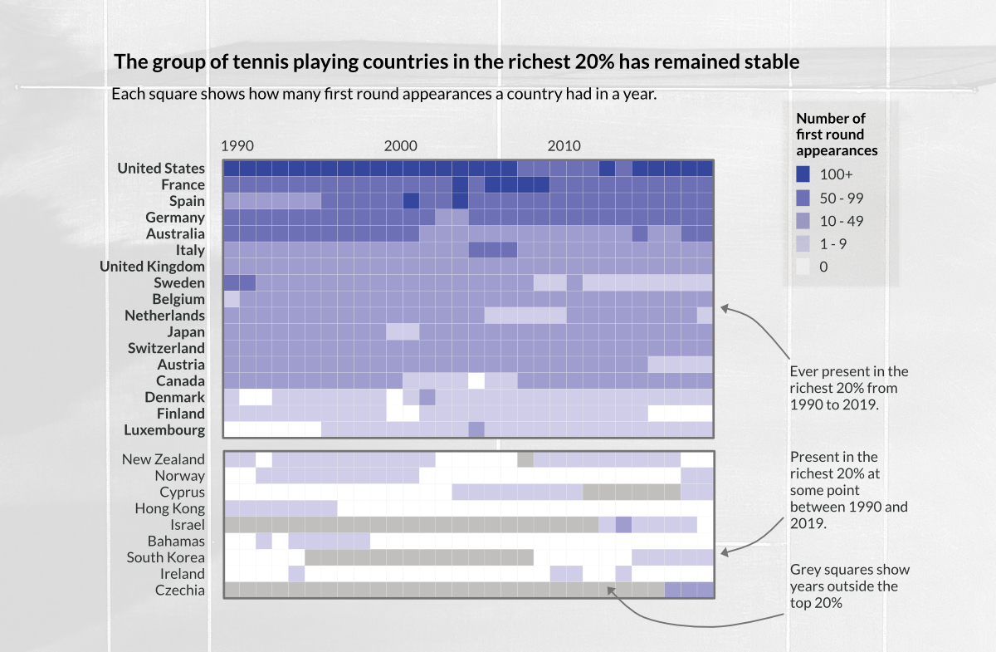

So, having ruled out one potential explanation for the trend, let’s focus in why the dominance of the richest countries declined between 1990 and 2008.

If we compare each countries performance - in term of number of first round Grand Slam appearances - between 1990 and 2008, we can four three groups. Countries where performance has:

* Improved (France and Spain);
* Been fairly stable (most countries in the top 20% richest);
* Declined (Australia and Sweden);
* Declined a lot (the United States).

Looking at all the richest 20% countries together, they account for 78% of first round appearances in 1990. This has fallen to 54% of first round appearances by 2008. That fall of equates to 246 fewer first round appearances.

We have already identified the three countries with the biggest declines in performance. The United States, Australia and Sweden. Looking at just these three countries together, they account 40% of first round appearances in 1990. This has fallen to 14% of first round appearances by 2008, equating to 266 fewer first round appearances. The fading fortunes of just three countries was central to the decline in dominance of Grand Slam tennis by the richest 20%.

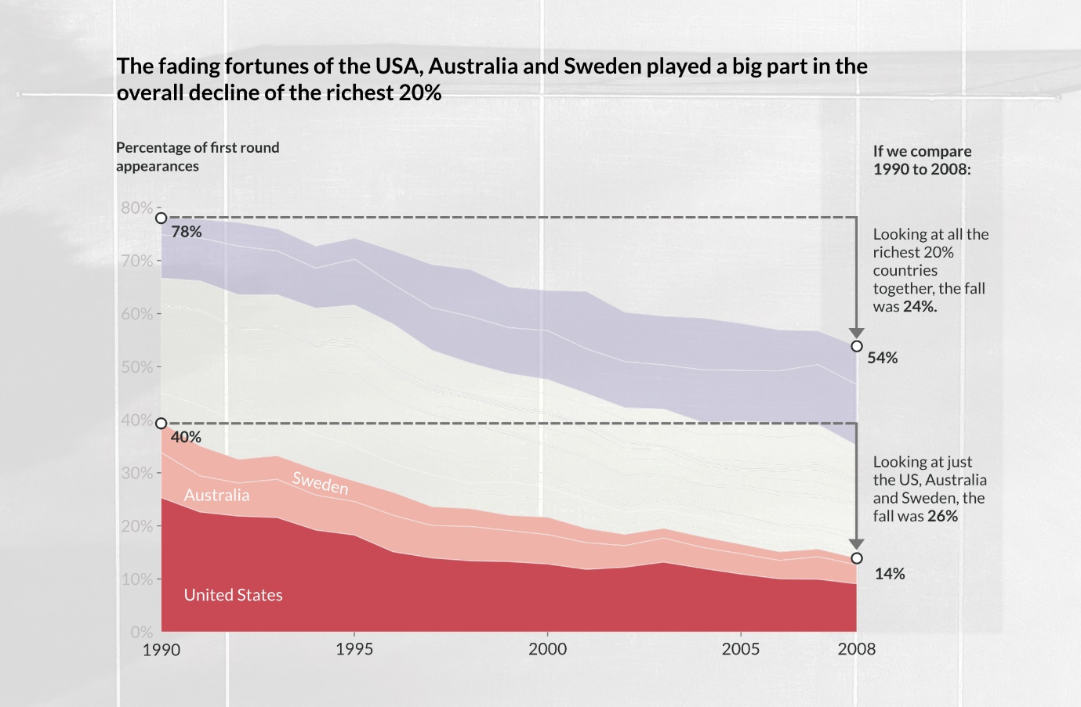

Zooming in even further, and looking at the transformation in the fortunes of United States, we can see a huge drop off. The United States accounted for a quarter of all players appearing Grand Slam singles in 1990. In the chart below it was hard to know which legendary players to note. With 106 different USA players appearing in Grand Slams in 1990. In was hard to know who to choose. In the end, there was not space on the chart for multiple Grand Slam winners including Andre Agassi. In contrast by 2008, it was much easier to pick out a few headline names, from a much smaller pool of players (41).

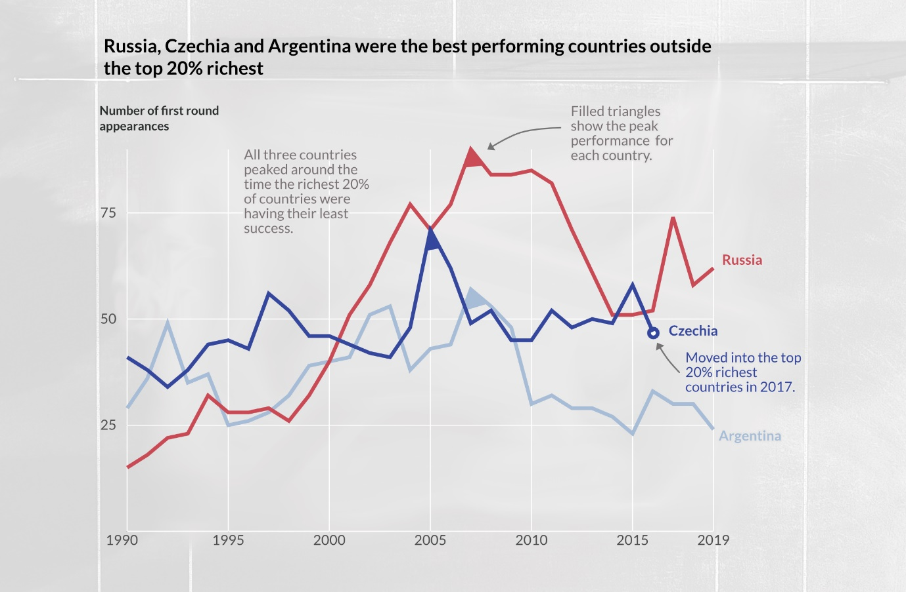

After hitting a low point in 2008, there was a resurgence in the fortunes of the richest countries in the years that followed. By 2019 the richest countries accounted for 60% of the first round appearances at Grand Slams. That is around the level they were at in 2002, but well below the where they were at in 1990 (78%).



